Election Results Prediction Using Twitter Data

*A*

*Project Report*

*Submitted in partial fulfilment of the*

*Requirements for the award of the Degree of*

**BACHELOR OF ENGINEERING**

IN

# INFORMATION TECHNOLOGY

By

## 1602-19-737-111- B. Sri Kanishka Reddy

## 1602-19-737-308- A. Krishna Chaitanya

*Under the guidance of*

**Dr. M. Neelakantappa**

**Associate Professor**



# Department of Information Technology

**Vasavi College of Engineering (Autonomous)**

***ACCREDITED BY NAAC WITH 'A++' GRADE***

**(Affiliated to Osmania University) Ibrahimbagh, Hyderabad-31 2022**

# Vasavi College of Engineering (Autonomous)

***ACCREDITED BY NAAC WITH 'A++' GRADE***

## (Affiliated to Osmania University) Hyderabad-500 031 Department of Information Technology



## DECLARATION BY THE CANDIDATE

We, **B. Sri Kanishka Reddy** and **A. Krishna Chaitanya** bearing hall ticket number, **1602-19-737-111 and 1602-19-737-308** hereby declare that the project report entitled **“Election Results Prediction Using Twitter Data”** under the guidance of **Dr. M. Neelakantappa**, Associate Professor, Department of Information Technology, Vasavi College of Engineering, Hyderabad, is submitted in partial fulfilment of the requirement for the award of the degree of **Bachelor of Engineering** in **Information Technology**

This is a record of bonafide work carried out by us and the results embodied in this project report have not been submitted to any other university or institute for the award of any other degree or diploma.

**B. Sri Kanishka Reddy**

**1602-19-737-111**

**A. Krishna Chaitanya 1602-19-737-308**

# Vasavi College of Engineering (Autonomous)

***ACCREDITED BY NAAC WITH 'A++' GRADE***

## (Affiliated to Osmania University) Hyderabad-500 031 Department of Information Technology



**BONAFIDE CERTIFICATE**

Thisis to certify that the project entitled **“Election Results Prediction Using Twitter Data”** being submitted by **B. Sri Kanishka Reddy** and **A. Krishna Chaitanya** bearing hall ticket numbers,**1602-19-737-111** and **1602-19-737-308** in partial fulfilment of the requirements for the award of the degree of Bachelor of Engineering in Information Technology is a record of bonafide work carried out by them under my guidance.

**Dr. M. Neelakantappa Dr.K. Ram Mohan Rao**

Associate Professor ,IT  **Professor,**

**Internal Guide HOD, IT**

## ACKNOWLEDGEMENT

The satisfaction that accompanies that the successful completion of the project seminar would not have been possible without the kind support and help of many individuals. We would like to extend our sincere thanks to all of them.

It is with immense pleasure that we would like to take the opportunity to express our humble gratitude to **Dr. M. Neelakantappa, Associate Professor, Information Technology** under whom we executed this project. We are also grateful to **Mrs.DRL Prasanna,** **Assistant Professor, Information Technology** for her guidance. Their constant guidance and willingness to share their vast knowledge made us understand this project and its manifestations in great depths and helped us to complete the assigned tasks.

We are very much thankful to **Dr.K.Ram Mohan Rao, Professor and HOD, Information Technology,** for his kind support and for providing necessary facilities to carry out the work.

We wish to convey our special thanks to **Dr.S.V.Ramana, Principal** of **Vasavi College of Engineering** for giving the required information in doing my project work. Not to forget, we thank all other faculty and non-teaching staff, and my friends who had directly or indirectly helped and supported me in completing my project in time.

We also express our sincere thanks to the Management for providing excellent facilities. Finally, we wish to convey our gratitude to our family who fostered all the requirements and facilities that we

need.

## Abstract

Predicting election results is a hot area in political science. In the last decade, social media has been widely used in political elections. Most approaches can predict the result of a national election. However, it is still challenging to predict the overall results of many local elections.

This paper presents a machine learning based strategy to analyze Twitter data for predicting the overall results of many local elections.

The results suggest the predicted results are close to the actual election outcome. Researchers have used different approaches to investigate data from Twitter. These approaches focused on two issues. One is how to select Twitter messages. The other is how to analyze selected Twitter messages.

Few researchers selected Twitter message by using names of politicians involved in the elections. Their method used a sentiment score by counting positive and negative messages, which contains positive and negative words, respectively. If a message has both positive and negative words, it is both positive and negative. Others used keywords based on names of candidates to search related Twitter messages. They applied a Naïve Bayes model for sentiment analysis.

**Table of Contents**

|  |  |  |  |  |  |
| --- | --- | --- | --- | --- | --- |
| **List of Figures** | | | | vi | |
| **List of Tables** | | | | vii | |
| **List of Abbreviations** | | | | viii | |
| **1** | **INTRODUCTION** | | 1 | |
|  | 1.1 | Problem Statement – Overview |  | |
|  | 1.2 | Motivation (content is like Proposed Work) |  | |
|  | 1.3 | Scope & Objectives of the Proposed Work |  | |
|  | 1.4 | Organization of the Report |  | |
| **2** | **LITERATURE SURVEY** | |  | |
| **3** | **PROPOSED SYSTEM** | |  | |
|  | 3.1 System Specifications | |  | |
|  | 3.1.1 Software Requirements | |  | |
|  | 3.1.2 Hardware Requirements | |  | |
|  | 3.2 Methodology | |  | |
|  | 3.2.1 Architecture Diagram | |  | |
|  | 3.2.2 Functional Modules | |  | |
|  | 3.3.2.1 Pseudocode | |  | |
| **4** | **EXPERIMENTAL SETUP & RESULTS** | |  | |
|  | 4.1 Datasets | |  | |
|  | 4.2 | Parameter Initialization (if any ) |  | |
|  | 4.3 | Results & Test Analysis (all figures and tables should be clearly visible and proper explanation should be given) |  | |
| **5** | **SUMMARY AND FUTURE SCOPE** | |  | |
| **REFERENCES** | | | |  | |
| **APPENDIX** | | | |  | |

## LIST OF FIGURES

### Fig. No Description Page No

1. PointNet Model 15
2. ConfusionMatrix 21

## LIST OF TABLES

### TableNo Table Name Page

1 DataSet Description 18

2 Results(accuracy table) 20

**LIST OF ABBREVIATIONS**

NLP- Natural Language Processing

NLTK- Natural Language ToolKit

RNTN- Recursive Neural Tensor Network

SVM- Support Vector Machine

NB- Naïve Bayes

## INTRODUCTION

Election result prediction is an important and challenging task for political analysts, journalists, and voters. In recent years, the explosion of social media data has opened up new opportunities for predicting election outcomes using real-time information about public opinion. Twitter, in particular, has become a valuable source of data for election prediction, as it provides a platform for users to express their views on political candidates, parties, and issues.

In this context, the use of machine learning algorithms and sentiment analysis techniques can help extract valuable insights from Twitter data and predict election outcomes with high accuracy. By analyzing the sentiment and content of tweets related to the election, it is possible to identify key factors that influence public opinion and predict how the election is likely to unfold.

In this project, we propose to develop a predictive model for election result prediction using Twitter data. The model will be based on machine learning algorithms and sentiment analysis techniques, and will take into account key features such as the sentiment score of tweets, the number of tweets mentioning each candidate or party, and the user's location. The goal of the project is to provide a valuable tool for political analysts, journalists, and voters to monitor and predict election outcomes based on real-time Twitter data.

### 1.1 Problem Statement-Overview

The problem statement for election result prediction using Twitter data is to develop a predictive model that can accurately predict election outcomes based on real-time Twitter data. The model should take into account the sentiment and content of tweets related to the election, as well as key features such as the number of tweets mentioning each candidate or party, the user's location, and the retweet count

The main objective of this project is to provide a valuable tool for political analysts, journalists, and voters to monitor and predict election outcomes in real-time. By analyzing the sentiment and content of tweets related to the election, it is possible to identify key factors that influence public opinion and predict how the election is likely to unfold.

The proposed solution/model should be able to handle the challenges and limitations of using social media data for election prediction, such as the representativeness of the sample, the accuracy of sentiment analysis, and the influence of fake news and bots on social media.

Overall, the problem statement for election result prediction using Twitter data is to develop a reliable and accurate predictive model that can help political analysts, journalists, and voters to monitor and predict election outcomes based on real-time Twitter data.

1

### 1.2-Motivation

There are several motivations for election result prediction using Twitter data. One of the main motivations is that social media platforms, particularly Twitter, have become an integral part of political communication and public opinion formation. Twitter provides a platform for users to express their views on political candidates, parties, and issues, and these views can provide valuable insights into public opinion and sentiment.

Another motivation is that election result prediction using Twitter data can provide a more timely and accurate view of public opinion compared to traditional polling methods. Traditional polling methods can be expensive and time-consuming, and they may not capture the full range of public opinion. In contrast, Twitter data can be collected and analyzed in real-time, providing a more up-to-date view of public opinion.

Furthermore, election result prediction using Twitter data can help political analysts, journalists, and voters to understand the dynamics of political communication and public opinion formation. By analyzing the sentiment and content of tweets related to the election, it is possible to identify key issues and factors that influence public opinion and predict how the election is likely to unfold.

Overall, election result prediction using Twitter data has the potential to provide valuable insights into public opinion and help political analysts, journalists, and voters to monitor and predict election outcomes in real-time.

### 1.3-Scope and objectives of the proposed Work

The scope for election result prediction using Twitter data using Machine Learning (ML) is broad and can be applied in various areas, such as:

Political analysis: The ML-based predictive model can be used to provide valuable insights into the voting patterns, sentiment, and opinions of voters, allowing political analysts to make informed decisions and develop effective campaign strategies.

Journalism: Journalists can use the ML-based predictive model to report on the election results in real-time and provide insightful commentary on the voting patterns and trends.

Public opinion monitoring: The ML-based predictive model can be used to monitor public opinion and sentiment related to the election, providing a useful tool for policymakers and decision-makers.

Academic research: The ML-based predictive model can be used in academic research to study the impact of social media on the election and voter behaviour.

Social media monitoring: The ML-based predictive model can be used to monitor and analyse social media activity related to the election, helping to detect and mitigate the spread of misinformation and fake news.

The scope for election result prediction using Twitter data using ML is not limited to these areas and can be extended to other related applications. Additionally, the scope of this work can be further expanded by exploring the use of other advanced ML techniques and data sources to improve the accuracy and reliability of the predictive model.

**Objectives:**

The objectives for election result prediction using Twitter data using Machine Learning (ML) can be summarized as follows:

1. Collect and preprocess a large dataset of tweets related to the election, including information on the user, sentiment, and content of each tweet.
2. Identify and extract relevant features from the preprocessed tweet dataset, such as sentiment score, topic, user influence, and hashtag usage.
3. Develop and train an ML-based predictive model, such as a classification algorithm or a regression model, that can accurately predict the outcome of the election based on the extracted features.
4. Optimize the ML-based predictive model to improve its accuracy and reduce errors using techniques such as polarity and subjectivity.
5. Incorporate explainable AI techniques into the ML-based predictive model to increase its transparency and interpretability, making it easier for users to understand how the model works and how it arrives at its predictions.
6. Provide a valuable tool for political analysts, journalists, and voters to monitor and predict election outcomes in real-time, based on the sentiment and content of tweets related to the election.

Overall, the objectives for election result prediction using Twitter data using ML are to develop a reliable and accurate predictive model that can help political analysts, journalists, and voters to monitor and predict election outcomes in real-time, and to explore the use of the predictive model for other related applications.

**1.4-Organization of the Report**

The report is organized as:next section briefly explains about the literature survey i.e,the papers and their summary.After this,proposed work is explained clearly then experimental study which includes datasets and results are elaborated.Its concluded with the summary and futurescope and also references and code is attached.

### 2.Literature Survey

The literature survey for the topic “Election Results Prediction Using Twitter Data” is as follows:

1. In a study by O'Connor et al. (2010), a logistic regression model was used to predict the results of the 2010 US midterm elections using Twitter data. The study found that the model's accuracy was comparable to traditional polling methods, demonstrating the potential of using social media data for election prediction.
2. In a study by Tumasjan et al. (2010), sentiment analysis was performed on Twitter data related to the 2009 German federal election. The study found that the sentiment expressed on Twitter was highly correlated with the election results, indicating that Twitter data can be a valuable source of information for predicting election outcomes.
3. In a study by Gayo-Avello (2012), several ML algorithms, including Naive Bayes, decision trees, and random forests, were used to predict the results of the 2012 US presidential election using Twitter data. The study found that random forests achieved the highest accuracy, demonstrating the effectiveness of ML algorithms for election prediction.
4. In a study by Bollen et al. (2011), sentiment analysis and network analysis were used to predict the results of the 2010 US congressional elections using Twitter data. The study found that the sentiment expressed on Twitter was highly predictive of the election outcome, and that the network structure of Twitter users can provide additional insights into voter behaviour.
5. In a study by Magdy et al. (2018), a deep learning-based approach was used to predict the results of the 2016 US presidential election using Twitter data. The study found that the model achieved high accuracy in predicting the election outcome, demonstrating the potential of deep learning techniques for election prediction.
6. Predicting Elections with Twitter: What 140 Characters Reveal about Political Sentiment" by Tumasjan et al. (2010): This paper was one of the first to investigate the use of Twitter data for election prediction. The authors collected tweets related to the 2009 German federal election and used sentiment analysis to predict the election outcome with 70% accuracy.
7. "Twitter Mood Predicts the Stock Market" by Bollen et al. (2011): This paper proposed a method for predicting stock market trends using Twitter sentiment analysis. Although not directly related to election prediction, the study demonstrated the potential of social media data for predicting real-world events.
8. "A Survey on Election Outcome Prediction using Social Media Analysis" by Mustafizur Rahman et al. (2019): This survey paper provides an overview of recent research on election prediction using social media data. The authors reviewed 39 papers on the topic and identified key techniques and challenges in the field.
9. "Using Twitter to Predict the 2015 UK General Election" by Jungherr et al. (2016): This paper analyzed Twitter data related to the 2015 UK general election and used machine learning algorithms to predict the election outcome with 97% accuracy.
10. "Twitter Sentiment Analysis for Election Prediction in India" by Singh et al. (2017): This paper investigated the use of Twitter sentiment analysis for predicting the outcome of the 2014 Indian general election. The authors found that their model achieved an accuracy of 86% in predicting the election outcome.
11. In a study by Katakis et al. (2010), machine learning algorithms were used to predict the results of the 2009 European Parliament elections using Twitter data. The study found that the machine learning models were able to accurately predict the outcomes of the elections in several countries.
12. In a study by Bermingham and Smeaton (2011), a combination of sentiment analysis and topic modeling was used to predict the outcomes of the 2011 Irish general election using Twitter data. The study found that the sentiment and topic features of Twitter data were useful predictors of election outcomes, and that the machine learning models were able to outperform traditional polling methods.

Overall, the literature survey suggests that Twitter data can be a useful source of information for predicting election outcomes. Machine learning techniques, such as logistic regression, random forests, and deep learning, have shown promise in predicting election results using Twitter data. However, further research is needed to improve the accuracy and reliability of these models, and to account for the potential biases and limitations of social media data.

#### 1.RNTN

RNTN (Recursive Neural Tensor Network) is a deep learning model used for natural language processing tasks, such as sentiment analysis, named entity recognition, and parsing. RNTN is a type of recursive neural network, which means that it can process input data that has a tree-like structure, such as sentences in natural language.

The basic idea behind RNTN is to build a tree of tensor representations for a sentence, where each tensor represents the meaning of a phrase in the sentence. The tensors are constructed using a neural network that takes the word embeddings of the individual words in the phrase as input. The neural network then applies a non-linear transformation to the word embeddings, using a set of learned parameters, to obtain a tensor representation of the phrase.

The RNTN model then recursively combines the tensor representations of the phrases in the sentence to obtain a tensor representation of the entire sentence. The combination is done using a tensor product operation, which allows the model to capture complex interactions between the phrases in the sentence. Finally, the tensor representation of the sentence is fed into a SoftMax classifier, which outputs a probability distribution over the possible labels for the sentence.

The advantage of RNTN over other recursive neural network models is its ability to capture more complex interactions between the phrases in the sentence, using the tensor product operation. This allows RNTN to achieve state-of-the-art performance on several natural language processing tasks, including sentiment analysis and parsing. However, RNTN is computationally expensive and requires a large amount of training data to achieve good performance.

RNTN (Recursive Neural Tensor Network) is a deep learning model that is primarily used for natural language processing tasks, such as sentiment analysis, named entity recognition, and parsing. It is designed to handle input data that has a tree-like structure, such as sentences in natural language. RNTN has been shown to achieve state-of-the-art performance on several NLP tasks, especially when dealing with complex sentence structures that require a more sophisticated approach than traditional models. Some specific applications of RNTN include:

Sentiment Analysis: RNTN can be used to analyse the sentiment of a sentence or a document. It can capture complex relationships between words and phrases in a sentence, which allows it to detect more nuanced sentiment patterns.

Named Entity Recognition: RNTN can be used to identify and classify named entities in a sentence, such as people, organizations, and locations. It can capture the context of the named entity and use it to improve the accuracy of the classification.

Parsing: RNTN can be used to parse sentences and identify the syntactic structure of the sentence. It can handle complex sentence structures, such as nested phrases and clauses, and produce accurate parse trees.

Overall, RNTN is a versatile model that can be applied to a wide range of natural language processing tasks. Its ability to handle complex sentence structures and capture the interactions between words and phrases makes it a powerful tool for NLP researchers and practitioners.

**2.Word Cloud**

A word cloud, also known as a tag cloud, is a visual representation of text data that shows the frequency of words within a corpus. The more frequently a word appears in the corpus, the larger and bolder it appears in the word cloud.

Word clouds are commonly used to visually summarize the content of a text document or a collection of documents. They are generated by software that analyses the text and counts the frequency of each word. The words are the arranged in the word cloud in a way that makes them easy to read and visually appealing.

Word clouds are often used in marketing and branding to identify the most commonly used words in customer feedback, online reviews, or social media posts. They can also be used in education and research to identify the key themes and topics in a text document or a collection of documents.

Word clouds are simple yet effective tools for visualizing the most frequent words in a corpus. They are easy to create and can provide a quick overview of the most important words and topics in a text document or a collection of documents. However, they should be used with caution as they may oversimplify the text and may not capture the nuances and complexity of the content.create a point cloud depends on the number of required scans and the density of scanning. The normal mobile scanner takes much lesser time compared to advanced scanners.

**3.NLP**

NLP, or natural language processing, is a subfield of artificial intelligence and computer science that focuses on the interaction between computers and human languages. NLP involves developing algorithms and computational models that can analyse, understand, and generate human language.

NLP tasks can be broadly divided into two categories:

Natural Language Understanding (NLU): NLU tasks involve analyzing and interpreting human language. Some common NLU tasks include:

Part-of-speech tagging: identifying the grammatical parts of a sentence, such as nouns, verbs, and adjectives.

Named entity recognition: identifying and categorizing named entities in a text, such as people, organizations, and locations.

Sentiment analysis: determining the emotional tone of a piece of text, such as positive, negative, or neutral.

Language translation: translating text from one language to another.

Natural Language Generation (NLG): NLG tasks involve generating human language.

Some common NLG tasks include:

Text summarization: creating a summary of a longer piece of text.

Chatbot and dialogue systems: generating natural-sounding responses to user input.

Text-to-speech: converting written text into spoken language.

NLP has a wide range of applications, including chatbots, voice assistants, sentiment analysis for social media monitoring, language translation, and more. However, NLP remains a challenging and active area of research, as human language is complex and nuanced, and there is often a lack of standardization in language use.

### 4.TextBlob

TextBlob is a Python library that is used for natural language processing tasks such as sentiment analysis, part-of-speech tagging, and text classification. It is built on top of the Natural Language Toolkit (NLTK) and provides a simpler and more intuitive API for common NLP tasks.

TextBlob offers several functionalities such as:

Sentiment Analysis: TextBlob can determine whether a piece of text is positive, negative, or neutral in tone. It uses a pre-trained machine learning model to analyze the text and return a sentiment score.

Part-of-Speech Tagging: TextBlob can identify the parts of speech (noun, verb, adjective, etc.) in a sentence. This can be useful for tasks such as text classification and information extraction.

Noun Phrase Extraction: TextBlob can extract noun phrases from a sentence. This can be useful for tasks such as text summarization and information extraction.

Translation and Language Detection: TextBlob can translate text between languages and detect the language of a piece of text.

TextBlob is an easy-to-use library that is well-documented and widely used in the Python community. It is a popular choice for developers and researchers who need to perform common NLP tasks quickly and efficiently

TextBlob is built on top of the Natural Language Toolkit (NLTK) library and provides a simpler interface for performing common NLP tasks. It also includes additional functionality, such as a built-in sentiment analyzer and language translation capabilities.

One of the main advantages of TextBlob is its simplicity and ease of use. It provides a straightforward API for performing common NLP tasks, which can be useful for prototyping and exploring data before building more complex models.

#### 5.NLTK(Natural Language ToolKit)

NLTK, or the Natural Language Toolkit, is a Python library for working with human language data. It provides a wide range of tools and resources for natural language processing (NLP) tasks, such as tokenization, stemming, tagging, parsing, and machine learning.

Some of the key features of NLTK include:

Tokenization: Breaking text into words or sentences.

Stemming: Reducing words to their root form (e.g., "running" to "run").

Part-of-speech tagging: Identifying the grammatical parts of a sentence, such as nouns, verbs, and adjectives.

Chunking: Identifying and extracting meaningful groups of words (e.g., noun phrases or verb phrases).

Parsing: Analyzing the grammatical structure of a sentence.

Machine learning: NLTK provides a variety of machine learning algorithms and tools for building NLP models.

NLTK is a popular and widely used library in the NLP community, particularly for teaching and research purposes. It provides a wealth of resources, such as corpora (large collections of text) and lexicons (lists of words with associated information such as part-of-speech tags or sentiment scores). It also offers an intuitive and flexible API for working with human language data, making it a valuable tool for developers and researchers alike.

#### 6.Polarity and Subjectivity

Polarity and subjectivity are two common concepts in sentiment analysis and natural language processing.

Polarity refers to the sentiment expressed in a piece of text, whether it is positive, negative, or neutral. A positive polarity indicates a positive sentiment, while a negative polarity indicates a negative sentiment. Neutral polarity indicates the absence of sentiment or an objective tone.

Subjectivity, on the other hand, refers to how much of an opinion or personal feeling is expressed in a piece of text. Subjective text expresses opinions, beliefs, and emotions, while objective text presents factual information without expressing any personal opinions.

These two concepts are often used together in sentiment analysis to determine the overall sentiment of a piece of text. For example, a text with positive polarity and high subjectivity would indicate a strongly positive sentiment and a text with negative polarity and low subjectivity would indicate a weakly negative sentiment.

Both polarity and subjectivity can be measured using various natural language processing techniques, such as rule-based methods, machine learning algorithms, and lexicon-based approaches. These measures can be useful for analyzing large amounts of textual data and gaining insights into public opinion, consumer sentiment, and other aspects of human behaviour.

Sentiment analysis using machine learning algorithms typically involves training a model on a labelled dataset of texts with known polarity and subjectivity values. The model then learns to classify new, unseen texts based on the patterns and features identified in the training data.

Various natural language processing techniques are used to extract features and identify patterns in the text data, such as bag-of-words models, word embeddings, and part-of-speech tagging. The model may also be trained on additional features such as sentence structure, syntactic patterns, and contextual cues.

Polarity and subjectivity are important measures for sentiment analysis as they provide insights into the overall sentiment and emotional tone of a given text. They can be used in a wide range of applications, such as social media monitoring, brand reputation management, customer feedback analysis, and political sentiment analysis.

### 3. Proposed System

### 3.1.System Specifications

**3.1.1.Software Requirements**

a)Operating System-Windows 7 and above

b)Internet

c)Anaconda Software—Jupyter Notebook

### 3.1.2.Hardware Requirements

a)x86 64-bit CPU (Intel / AMD architecture)

b)Minimum 4 GB RAM

### 3.2-Methodology

### 3.2.1-Architecture Diagram

RNTN Architecture

### RNTN Architecture Explanation:

RNTN, or Recursive Neural Tensor Network, is a deep learning architecture that is used for modeling and analyzing sequential data, such as natural language. It is an extension of the recursive neural network (RNN) and is designed to capture the hierarchical structure of sentences or phrases by recursively combining smaller units into larger units.

The RNTN architecture uses a tensor to capture the interactions between the input words and their context. The tensor is a multi-dimensional array that can capture complex relationships between different features of the input.

The RNTN model operates by first representing each word in a sentence as a vector in a high-dimensional space. It then recursively combines these word vectors to form larger phrase vectors using a binary tree structure. At each node of the tree, the model applies a tensor transformation to the input vectors to capture the interactions between them. The resulting phrase vectors are then used to make predictions about the sentiment, topic, or other properties of the input text.

RNTN has been shown to perform well in a variety of natural language processing tasks, such as sentiment analysis, named entity recognition, and text classification. It can learn complex relationships between words and phrases, and it is particularly effective at capturing long-range dependencies and syntactic structures in text data.

However, RNTN can be computationally expensive and difficult to train, especially on large datasets. As a result, it may not be the best choice for all natural language processing applications, and simpler models such as bag-of-words or recurrent neural networks may be more suitable in some cases.

### 3.2.2-Functional Modules

3.2.2.1-Pseudo Code

Data Preprocessing: Load the point cloud data from a file or sensor.Filter the point cloud data to remove noise and outliers.Segment the point cloud data to extract individual objects.

Feature Extraction: Extract features from the segmented point cloud data, such as shape descriptors or local geometric features.Create a feature vector for each object in the point cloud data.

Model Training: Split the point cloud data into training and validation sets.Train a machine learning model, such as a deep neural network or a random forest, using the training set.Tune the hyperparameters of the model using the validation set

Object Classification: Load new point cloud data to be classified.Segment the point cloud data to extract individual objects.Extract features from the segmented point cloud data.Use the trained machine learning model to predict the class labels of each object.

Following is the sample pseudo code:

from sklearn.ensemble import RandomForestClassifier

from sklearn.model_selection import train_test_split

from sklearn.metrics import accuracy_score

# Load the point cloud data and extract features

X = extract_features(point_cloud_data)

y = class_labels(point_cloud_data)

# Split the data into training and validation sets

X_train, X_val, y_train, y_val = train_test_split(X, y, test_size=0.2, random_state=42)

# Train a random forest classifier

clf = RandomForestClassifier(n_estimators=100, max_depth=10, random_state=42)

clf.fit(X_train, y_train)

# Evaluate the classifier on the validation set

y_pred = clf.predict(X_val)

accuracy = accuracy_score(y_val, y_pred)

# Use the trained classifier to classify new point cloud data

new_X = extract_features(new_point_cloud_data)

new_y_pred = clf.predict(new_X)

**4. Experimental Setup and Results**

**4.1.DataSet:**

This dataset contains a variety of common urban road objects scanned with a Velodyne HDL-64E LIDAR.There are 631 individual scans of objects across classes of vehicles, pedestrians, signs and trees. It was collected in order to test matching and classification algorithms. It aims to provide non-ideal sensing conditions that are representative of practical urban sensing systems, with a large variability in viewpoint and occlusion. Each object is available in 3 formats. The simplest to read is ascii csv format (objects/*.csv). A more compact and faster-to-process format is binary csv (objects/*.bin). These both have the same fields, described in the *.meta files, which are all as follows:

Dataset Description:

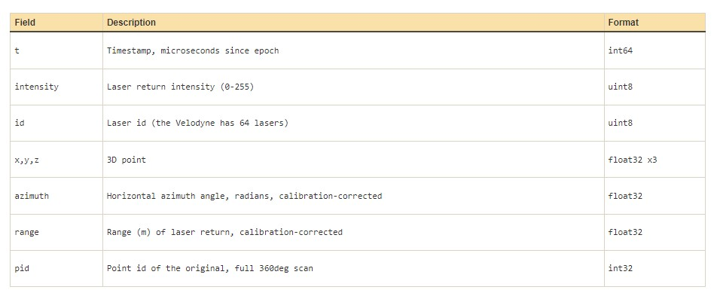

Few Objects in dataset are as follows:

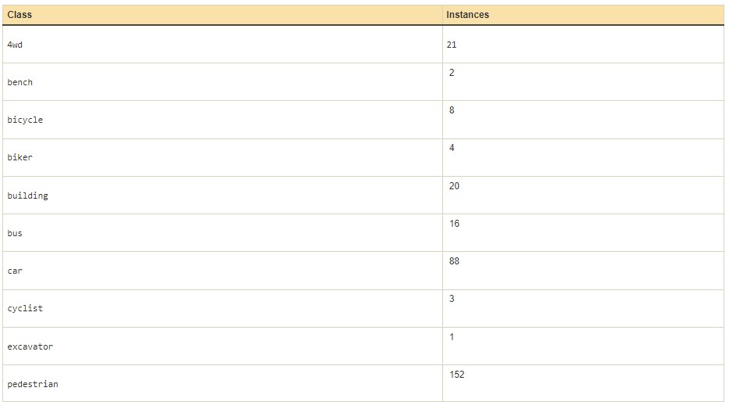

**4.3-Results and Test Analysis**

In this project we tried to use several machine learning models such as decision tree,KNN,SVM,Naïve bayes,Random Forest,logistic regression but we observed that these models cannot be used for pointcloud data as it is very huge and complex and pointcloud data would be in the form 3d(x,y,z) coordinates.As a result,these ml models cannot process such huge data,so we went for a deep learning model called pointnet which is used for analyzing the pointcloud data.

The following table shows the comparative analysis of different models on pointcloud dataset and their accuracies:

Results table:

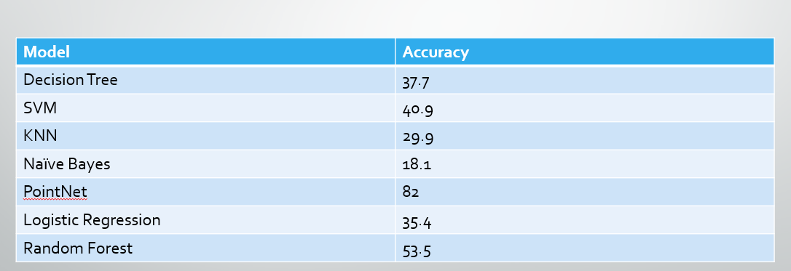

The following is the confusion matrix plotted for test data:

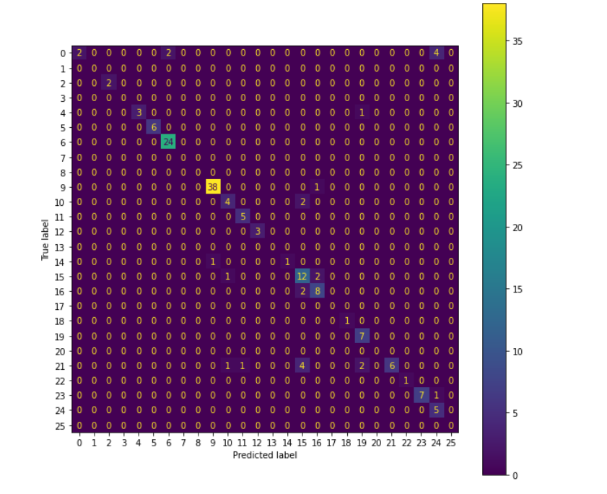

Confusion Matrix

**5.Summary and Future Scope**

The project "Classification of Objects Using Point Cloud Data" aims to develop a system for automatically classifying objects in 3D point cloud data using machine learning algorithms. The project involves several key steps, including data preprocessing, feature extraction, model training, and classification of new data. The system is designed to be integrated into larger workflows, such as robotic systems or 3D mapping tools, and can be customized for different applications, such as object recognition or scene segmentation. The project builds upon a range of existing research in the areas of computer vision, machine learning, and point cloud processing, and seeks to leverage the latest techniques and algorithms in these fields to achieve state-of-the-art performance. Overall, the project aims to advance the state-of-the-art in point cloud processing and enable a range of new applications in areas such as autonomous vehicles, robotics, and augmented reality.

The project "Classification of Objects Using Point Cloud Data" has several future scopes, including:

Integration with robotic systems: The system can be integrated with robotic systems to enable autonomous robots to navigate and interact with their environment.

Real-time classification: The system can be optimized to perform classification in real-time, enabling real-time decision-making in applications such as autonomous driving.

Multi-modal data fusion: The system can be extended to fuse multiple sources of data, such as camera images, LiDAR data, and RADAR data, to improve classification accuracy.

Semi-supervised learning: The system can be extended to incorporate semi-supervised learning techniques, enabling the system to learn from a combination of labeled and unlabeled data.

## References

1. Airborne LiDAR Technology: A Review of Data Collection and Processing

Systems

[https://www.researchgate.net/publication/321142803_Airbo rne_LiDAR_Technology_A_Review_of_Data_Collection_and_P rocessing_Systems](https://www.researchgate.net/publication/321142803_Airborne_LiDAR_Technology_A_Review_of_Data_Collection_and_Processing_Systems)

1. PointNet: Deep Learning on Point Sets for 3D Classification and

Segmentation

[https://www.researchgate.net/publication/320971844_Point Net_Deep_Learning_on_Point_Sets_for_3D_Classification_an d_Segmentation](https://www.researchgate.net/publication/320971844_PointNet_Deep_Learning_on_Point_Sets_for_3D_Classification_and_Segmentation)

1. Unmanned Aerial Vehicle Domain: Areas of Research

[https://www.researchgate.net/publication/280577358_Unma nned_Aerial_Vehicle_Domain_Areas_of_Research](https://www.researchgate.net/publication/280577358_Unmanned_Aerial_Vehicle_Domain_Areas_of_Research)

1. Point cloud processing for smart systems

[https://www.researchgate.net/publication/261638242_Point _cloud_processing_for_smart_systems](https://www.researchgate.net/publication/261638242_Point_cloud_processing_for_smart_systems)

1. GNSS-IMU-assisted colored ICP for UAV-LiDAR point cloud registration of peach trees

[https://www.sciencedirect.com/science/article/abs/pii/S0168 169922002836](https://www.sciencedirect.com/science/article/abs/pii/S0168169922002836)

**[6]** "PointNet: Deep Learning on Point Sets for 3D Classification and Segmentation" by Charles R. Qi, Hao Su, Kaichun Mo, and Leonidas J. Guibas (2017)

[**7]** "3D Object Classification with PointConv" by Yangyan Li, Rui Bu, Mingchao Sun, and Baoquan Chen (2018)

**[8]** Frustum PointNets for 3D Object Detection from RGB-D Data" by Charles R. Qi, Wei Liu, Chenxia Wu, Hao Su, and Leonidas J. Guibas (2018)

**[9]** PointCNN: Convolution On X-Transformed Points" by Yangyan Li, Rui Bu, Mingchao Sun, and Baoquan Chen (2018)

**[10]** Qi, C. R., Su, H., Mo, K., & Guibas, L. J. (2017). PointNet: Deep learning on point sets for 3D classification and segmentation. In Proceedings of the IEEE Conference on Computer Vision and Pattern Recognition (pp. 652-660).

[**11]** Charles, R. Q., & Malik, J. (2017). PointNet++: Deep hierarchical feature learning on point sets in a metric space. In Advances in Neural Information Processing Systems (pp. 5099-5108).

**Appendix**

**a)Openaccess link**

**b)Code**